# A Happy Reunion in the Dolomites

All is well with the world once again. Not that it was horrible these past 3.5 months . . . I had some really wonderful experiences over the summer that I would not trade for anything. But it is so exquisite to be back in the same breathing space as my husband for a while. I treasure the time we get to be together, not only because it goes by so fast during each 90 day segment, but because he is just such a great guy to hang out with.  We don't have to do anything spectacular for it to be blissfully wonderful. We could just be making stroganoff for dinner in the kitchen together, like tonight, for example. I did some chopping, he did lots of stirring and stove-tending. We might chat a little, or we might just silently work near each other. Both scenarious are equally peaceful and comfortable. I will take an evening of doing laundry together and watching a show on the couch, just as much as I will take a weekend up in the Italian Alps with my best hiking buddy.

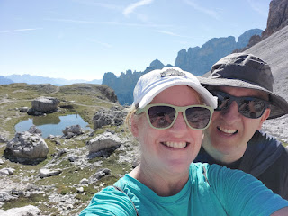

Last Monday, August 28th:

(seems like forever ago) I finished decorating for Christmas before I left Idaho. The Elf Tree is officially set up and ready now, downstairs in the family room.

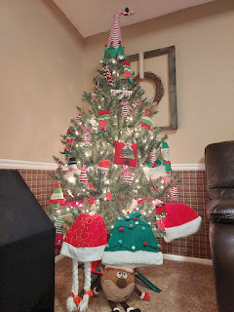

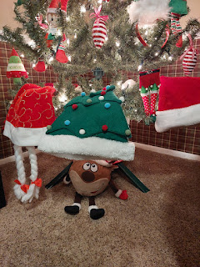

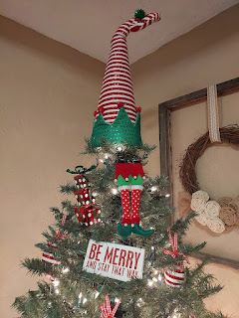

Later that afternoon, Benson and I drove up to Rigby to say goodbye to Grandpa Phil and Bev. I always wonder if the hugs we give will be the last one or not . . . not to be morbid, but rather to make them an extra good one. :)

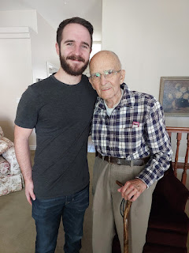

Next, we picked up some Mexican food in Rexburg and took it out to the cemetery. I wanted to see Coy's new headstone, which had been recently placed and secured. We brought camping chairs to sit in, and it was just delightful.

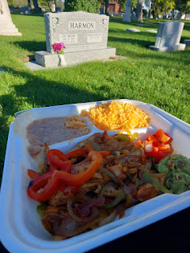

While it was not Benson's first choice for a picnic spot, he quickly settled in, and as we ate, we had an impromptu conversation about burial vs cremation and what his preference is. He shared that he would prefer to be cremated and to have his children sprinkle his ashes someplace meaningful, like up in the beautiful mountains, for example. I was surprised that he had such a specific vision of what he wanted, but I was grateful for the opportunity to have that conversation, since it likely would never have come up at any other time.

It felt like we had a nice evening picnic with Coy, Jonny, Philip (Scott's brother), and Grandpa Wes and Grandma Helen. I knew deep down that Coy was the most joyful that we took the time to do this, because she was all about gathering family around a good meal.

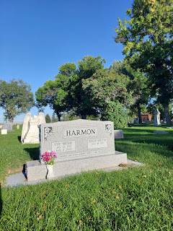

I had asked Amber what she would like me to do for Jonny's birthday, since I wouldn't be here in November. It was her suggestion that we bring a snack or a treat and just eat it nearby and hang out with him. So that's how it all came to be. The Harmons are all in a row, right next to each other, which is fantastic. The weather was perfect, and we had a good time.

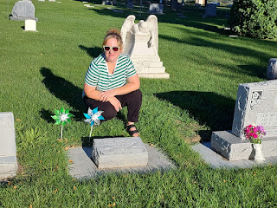

We drove into town to visit Rich and Andrea Garner after our picnic in the cemetery. Benson had not seen them in a LONG time, and we had a great visit for about an hour or so.

Rich, holding his 3 month old grandson, Avery, and Andrea making big smiles at him . . . :)

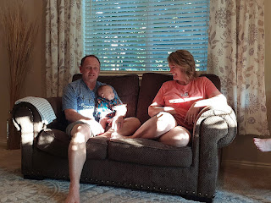

There was a beautiful sunset over Rigby Lake on the drive home . . .

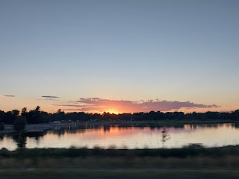

Tuesday, August 29th:

I went to the temple one more time, early in the morning. While I didn't go as often as I would have liked over the summer, I'm still grateful for each time that I did go. I like to spend a few extra minutes in the peaceful and serene Celestial Room so I can just be quiet for a while and pray and ponder. I felt like my Heavenly Father was pleased with my efforts to care for and spend time with Benson over the summer.  We had a good time together these past couple of months, along with some wonderful conversations.

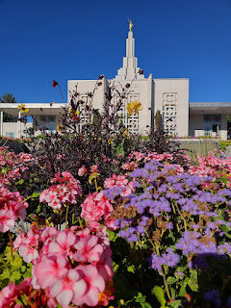

In between packing and organizing around the house, Benson got himself ready and packed up to go as well. He left in the late afternoon to drive over to Mountain Home Air Force Base. He has my car for now, until his car gets fixed in October.

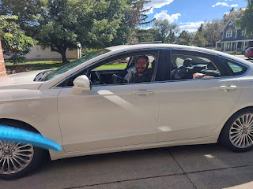

I thought it was cute how he buckled in some important things for the 3.5 hour drive . . .

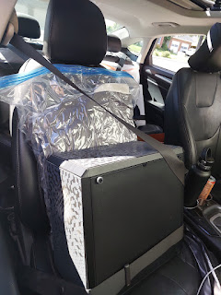

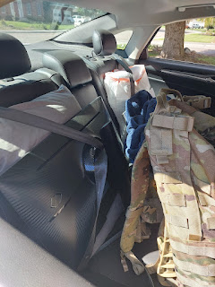

He ended up driving an extra hour to spend the night with Mike and Carol in Boise (Scott's older sister), since the hotel on base was full. I'm so glad that family lives nearby and that they took him under their wing for me.

Wednesday, August 30th:

I hustled and bustled for 8 solid hours, getting the house cleaned from top to bottom. I swept, dusted, vacuumed, washed bedding and put beds back together, emptied out the fridge, etc. I only had about 10 minutes at the end to change my clothes and be ready with my suitcases on the front porch, so I could get a ride to the airport with my friend, Barb Vance.

Kim Parkinson came over one more time to give me a hug. She had already come over the night before, so we could go over some details as she begins caring for our home again while I'm gone. I am so grateful for their family's devotion and friendship!!

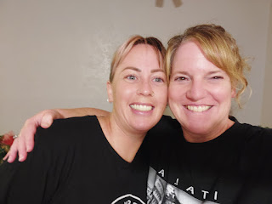

I also got a video call from Benson. It was so great to see him so happy and fired up about this next phase of his life. It was also cute to see him without the beard, and with a clean-shaven face instead. I'm not sure why it's such a trend to sport a mustache these days . . . but he looked handsome in spite of it, ha ha.

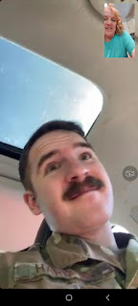

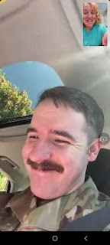

He reported that he likes everyone that he'll be working with, and that he was especially impressed with the on-base housing. He showed me through the video call as he drove around the streets of the base, and it looked so neat and tidy with big family homes everywhere. He said it felt like a real community there, with a golf course, a gas station, green manicured lawns, etc. The off-base housing, in the actual city of Mountain Home, weren't nearly as nice, in his opinion. It made me happy to see him so happy.

I picked one of the TWO apples on my Jonny Tree, so I could taste it before I left. It might have needed one extra week or two on the tree, because it was a bit tart, but it was still delicious! I couldn't reach the other apple, so I just focused on this one. Minus one slice that I shared with Kim, I ate the rest.

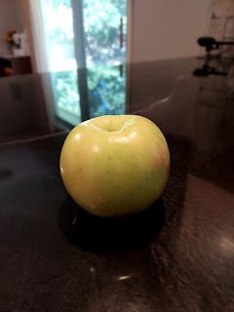

When Barb dropped me off at the airport, I had to do some suitcase juggling. My bigger suitcase was over the limit of 50 lbs. (52) and the smaller one was just 38 lbs. I stepped over to the side so I could move some heavier items into the smaller suitcase. At the re-weighing, I had evened things out a bit. (48 lbs and 43 lbs)

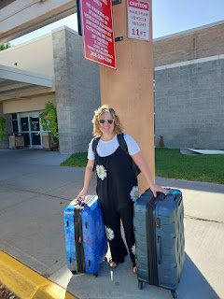

And off I went . . .

Thursday, August 31st:

The flights all went splendidly, except for the last leg from Munich to Venice. It was delayed by an hour. But I did get some sleep through the night, which I was grateful for. I finally tried a gizmo that I bought several months ago, but was never brave enough to try it until now. It's a foot sling that you can hang from the tray table so you have a place to rest your feet instead of just resting them on the floor. It is literally a game changer for someone short like me . . . I used that thing during the entire flight from Denver to Munich - almost 10 hours. You have to open the tray table to clip the strap around it, but then you can put the tray table up and just rest your feet below. It's like a little hammock that hangs underneath. Ingenious!!

On my last flight from Munich to Venice, I ended up sitting by this guy. A husband and wife wanted to sit together but had seats apart, so I ended up switching over to this other row so they could sit together. He was a beefy guy who obviously had spent countless hours at the gym, and was covered in tattoos, but he was the nicest guy!! I learned that he grew up and lives in Northern Italy but works in Canada on the oil pipelines. He had a thick Italian accent, but spoke excellent English. He was on his way home because his wife was due to have their first baby in the next two weeks. It will be a little boy, and they are planning to name him Robert, after his grandfather who passed away about 15 years ago. I jokingly asked if he was planning to teach his son everything he knows at the gym, and he thoughtfully replied, "If that's what he's interested in doing, then yes, I will teach him. But I will not make him do anything he doesn't want to do." Enough said. I learned that even though he looked like a strong and commanding man on the outside, he was a very kind and gentle man underneath. Never judge a book by its cover.

(I snuck in a quick photo while he slept for a bit . . . )

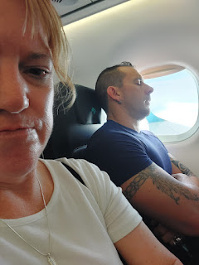

Coming into Venice . . .

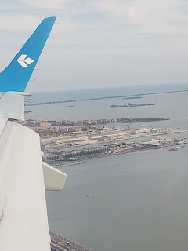

Hooray!! Even though I look trashed, which I was, I was so happy to be back with Scottie. XOXO

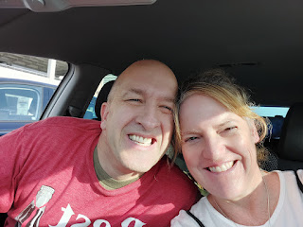

Scott made us dinner, while I laid down on the couch with my eyes closed. I was sooooo tired . . .

Friday, September 1st:

I had a very good night of sleep and even slept in a little.

How nice

. I had been hustling for DAYS back in Idaho, so it was a gift to be able to have a lazy morning for once . . .

Eventually we got ready and on the road to have an epic adventure together. We drove about 3 hours north and slightly west to visit the Terrazza Marmolada. It's a chairlift ride up to 10,000+ feet where there's an observation deck and views galore. Unfortunately, Google sent us PAST the chairlift by several minutes, and we ended up on a trail that was at the BOTTOM of where the chairlift ride ascended up to . . . Oh Google . . . sigh . . . you were so close. By the time we figured it out and drove back, they had just closed for the day. Darn it.

But . . . , when you get lemons, you can still make some lemonade. So that's what we did. We found a couple other areas to explore and get out of the car for a bit.

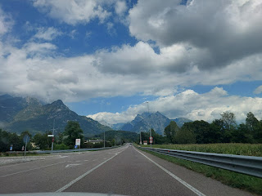

The sheer size of the Dolomites is just incredible. The closer we got, the more unbelievable their stature became.

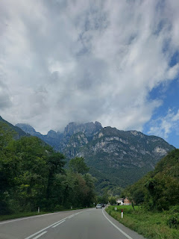

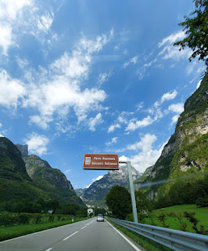

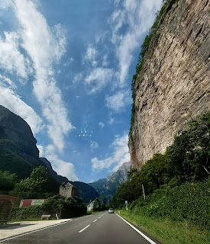

Video of a little portion of our drive, while listening to the end of the song "Purple Rain" by Prince, ha ha.

(44 seconds)

https://photos.app.goo.gl/aqzAcYAuhCUY4Ba96

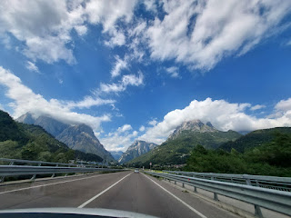

Below: Check out the little community of houses up on the mountain where it's all green. (click on the photo to enlarge) I don't know how they get up there, but it's gotta be a series of switchbacks . . .

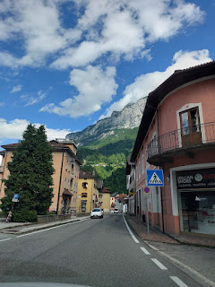

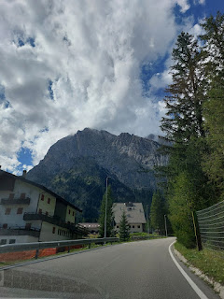

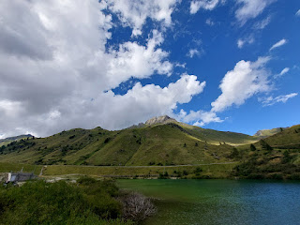

Google sent us to a tiny little road that cars shouldn't even be driving on, ha ha. We parked and got out to explore on foot a bit, because we had been in the car for a long time . . .

Scott is in this next photo. See if you can find him. (click photo to enlarge)

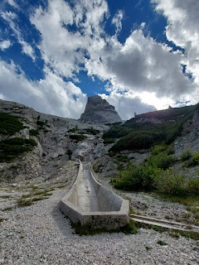

Forgive my French, but this is a dam lake . . . it's called Lago di Fedaia.

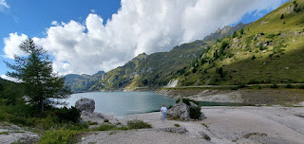

Here is the dam . . .

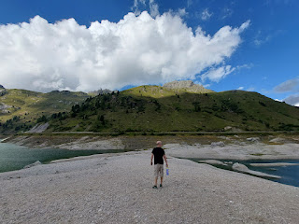

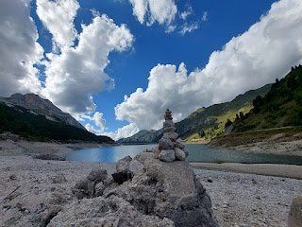

We saw the cutest herd of sheep and goats next to the road between the dam lake and Ciamp Dello Stanzon, slightly south.

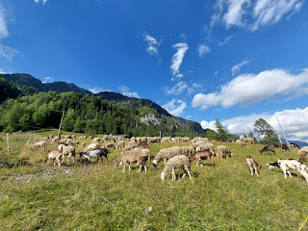

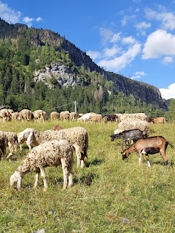

Heading up and over the mountains near Selva di Cadore.

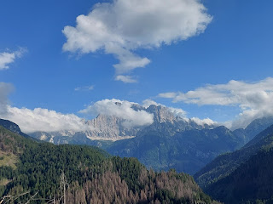

Video as we drove through a portion of the Dolomites National Park: (25 seconds)

https://photos.app.goo.gl/Hebob3gWcaFBRitHA

The massive valley that holds the city, Cortina d'Ampezzo, was quite impressive. It sprawled for miles in between all the nearby mountains.

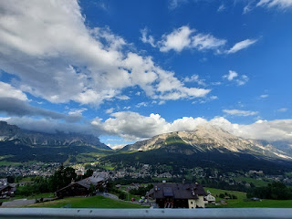

The little river that ran through town was a light turquoise, but also crystal clear. So pretty!

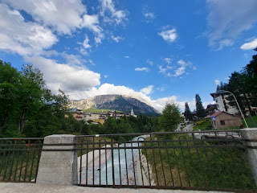

We made it to our hotel (Hotel Croda Rossa) about 30 minutes later. It was super cute!!

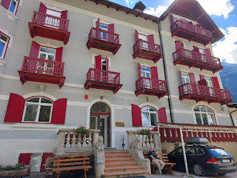

We chose to eat at the hotel that evening so we didn't have to drive anymore, ha ha. I ordered two little mini quiche-type things, with vegetables in them. They were so tasty! Scott ordered a breaded pork cutlet known as schnitzel, with potatoes on the side. The dish in between us was polenta with a weird moldy/salty cheese wedge in the center. It was "meh". I wished it were hotter instead of room temperature.

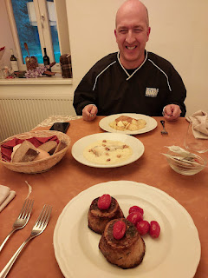

Saturday, September 2nd:

We got up extra early so we could be out the door as soon as we ate breakfast. Unfortunately, the breakfast buffet did not begin until 7:30 a.m., but we were the first ones to go in once they opened the doors. We had read that if you didn't get to the Tre Cime Toll Booth by 9:00 a.m. then you probably wouldn't get a parking spot. It was a 25 minute drive to get there, so we needed to hustle.

There was a huge long line of cars waiting to pay at the Toll Booth, so we just crawled along for several minutes, hoping that there would be a spot left by the time we got up there. I took this next shot through my open car window.

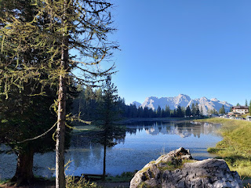

Take a careful look at this next photo. Notice where we are in the lineup of cars, compared to the mountain. Now find the substantial-looking ledge halfway up the mountain.  That's where the giant parking lot is for the trailhead. The toll booth fee is to pay to be on the switchback road between here and there . . . yikes. As we got closer to the toll booth, we could see the electronic sign with the current number of parking spaces still available up on the mountain. I think as we paid for ours, the number ticked down to 99 spots left, with several cars behind us . . . (There's also a bus to take you up if you don't want to drive up and park.)

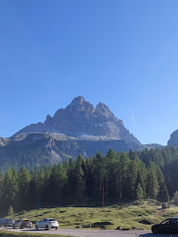

Here is the view from where we parked . . .

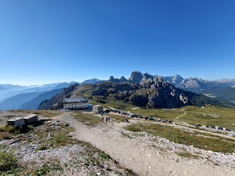

Oh boy . . . the weird potty thing again . . . why is this better than a sit-down toilet?

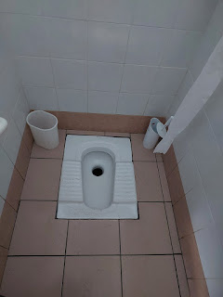

Rifugio Auronzo is the beginning of the Tre Cime (pronounced "tray CHEE-may") Trailhead. It's a mountain hut (or a warming hut) as you loop around the massive three peaks of Tre Cime. This is where we were able to use the potty before we started out. (for a fee of one euro, of course)

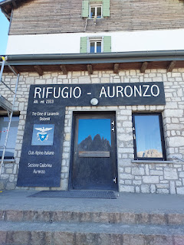

Here are a couple different views of the mountain ranges from Rifugio Auronzo.

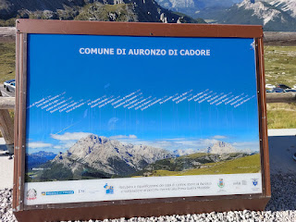

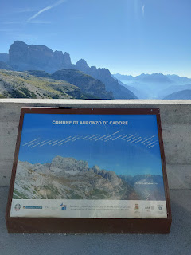

And off we went . . .

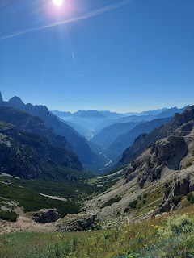

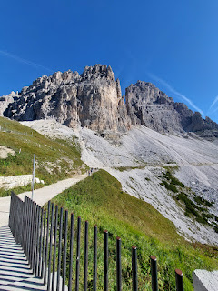

The trail is wide and flat for a long while, which allows for all kinds of hikers, even those in motorized wheelchairs.

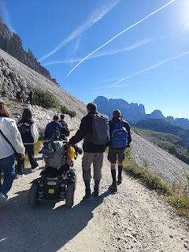

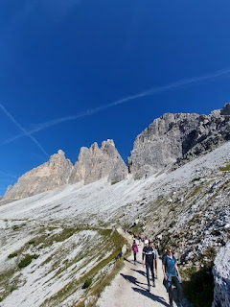

There were cows grazing all over the hillsides, with their beautiful clanging neck bells.

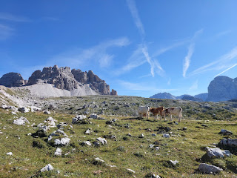

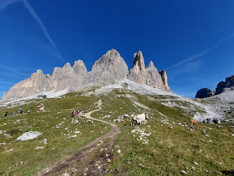

Video of the cows and the scenery: (30 seconds)

https://photos.app.goo.gl/mSJiCvQGsXxi6QzK6

There was what appeared to be a large white bull with intimidating horns. But "she" also had udders . . . so how does that work exactly?? She was very clearly in charge, though.

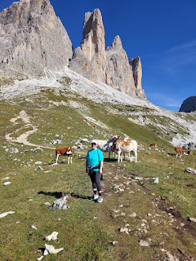

At the next hut, a smaller hut, there was a split in the trail. Each route takes about 30 minutes, but they both converge at the top of the gravelly-looking saddle to the left of the rocky peaks. We chose to take the path going to the right (because "Choose the Right") . . . and mostly because it looked a little less intimidating with its steady incline, as opposed to going straight-up vertical if we had gone to the left.

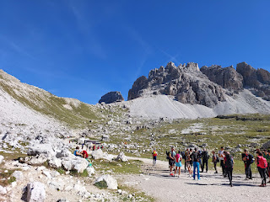

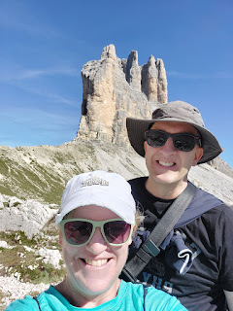

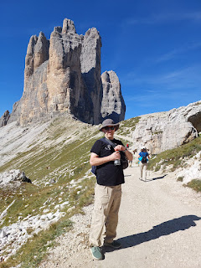

Video as we got close to the meeting point of the two trails on top of the saddle: (19 seconds)

https://photos.app.goo.gl/MQ9Y2Hri4vjJQieBA

There were lots of cairns on top of the saddle . . .

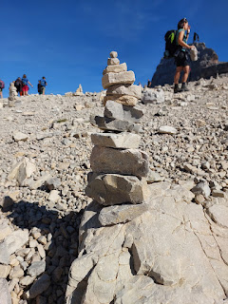

This photo does not even begin to convey just how huge those three peaks are . . .

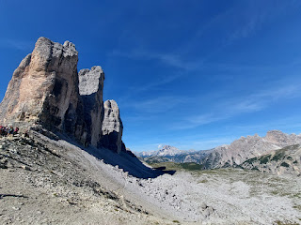

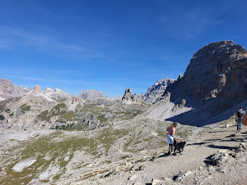

But let me just remind you that the name of the trail is Tre Cime. This hike is all about those three massive peaks. We hiked in a huge 6.9 mile loop around them, traversing several peaks and canyons along the way. See if you can see the tiny little trail on the lower left (below). That's where we came down from the saddle. Maybe that will put the size of the peaks into proper context.

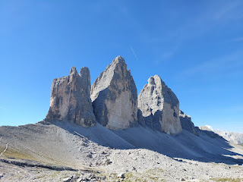

The next hut, Drei Zinnen, is FAR, far away. You can see its red roof on top of a ledge across the canyon. (photo below) It took us about an hour to get there.

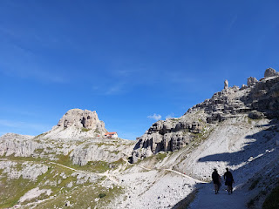

Drei Zinnen Hutte - to the left of the trail marker and only about 10 more minutes of vertical trail to get up there!! Hooray!

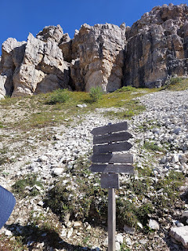

Here was a nice place to just catch our breath in those last 10 minutes. I did a lot better than I would have if I hadn't used my inhaler earlier.

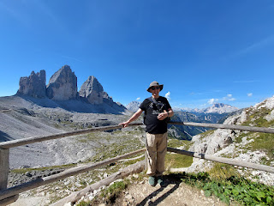

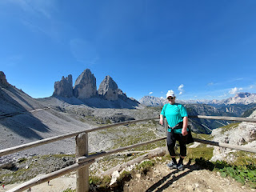

Once we got up to the Hutte, I saw that we had a fun option for lunch: a plate with 2 sausages and a bun. (mustard optional) I grabbed us one plate that we could share, since neither of us was overly hungry.

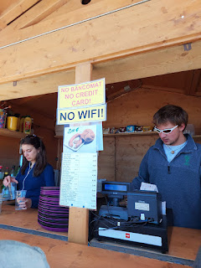

Buon appetito at 8300 feet!!

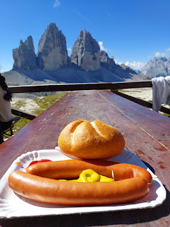

I had read on a travel blog that there was a spot behind the Drei Zinnen Hutte that is well worth seeing. There are two alpine "lakes" with bright turquoise water. I say "lakes" because they were more like large ponds, but still very beautiful.

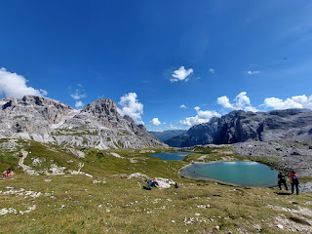

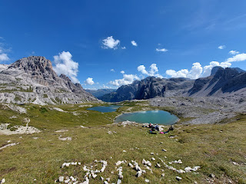

It was time to hit the trail again. As we descended that steep section below the Hutte, we passed a couple of nuns! What a variety of hikers we passed during the day: a disabled man in his motorized wheelchair, nuns, young parents carrying their babies and toddlers on their backs, all sizes of dogs on leashes, and even a man with a very stiff gait using hiking poles. (He might have had a prosthetic leg . . .) Lots of languages along the trail, too, but mostly Italian and German.

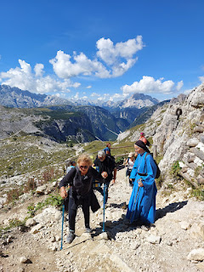

The next section of trail was the most difficult in my opinion. We had to go from the Hutte (up on that high ledge) all the way across the "valley" to the far right side of the Tre Cime and then back around to the front. You can size it up in the photo below, since you can see the trail way off in the distance . . . (click the photo to enlarge).

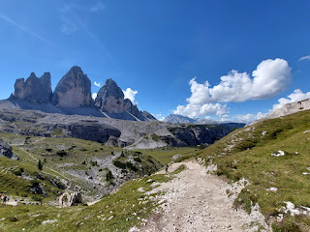

The more closely you look at these photos, the  more you realize the size of the mountains and canyons VS the size of the trail . . .

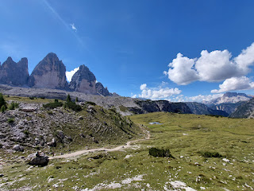

This was the steepest uphill section . . . I think we stopped 4 or 5 times to breathe. (More for my benefit, of course!)

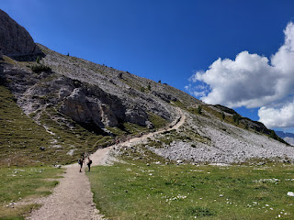

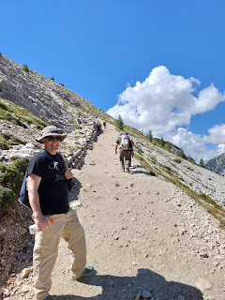

Video about halfway up that stretch: (15 seconds)

https://photos.app.goo.gl/axkgXALtCWXPRbn1A

The view about 3/4 of the way up . . .

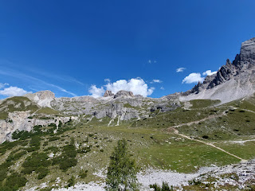

Finally, we made it over to the Tre Cime again. Hip Hip Hooray!

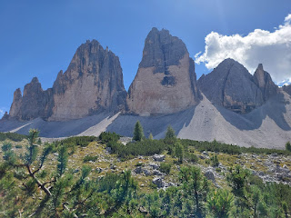

There was a delicious supply of cold water to fill up our water bottles by the last hut, Malga Langalm.

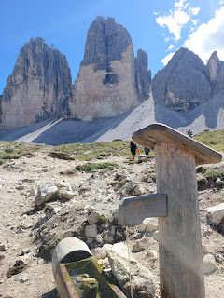

Video of the creek running from hither to yon, we couldn't tell where it originated from: (21 seconds)

https://photos.app.goo.gl/tpaoVPHoVTbT8gjw9

We rested for a few before pushing onward . . .

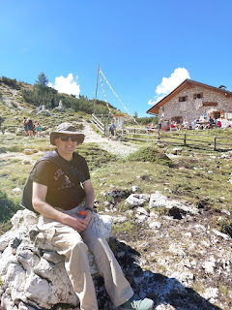

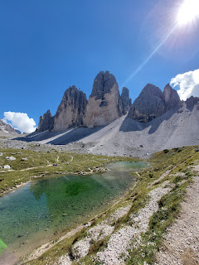

This pretty much encapsulates how we felt 3/4 through the hike . . . LOL

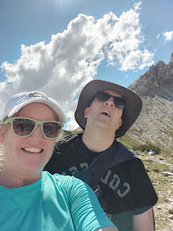

Video showing how far we'd come - all the way from the Drei Zinnen Hutte: (23 seconds)

https://photos.app.goo.gl/G1jP9cqFtAzwixpv6

Video of the narrow trail far above the valley floor: (12 seconds)

https://photos.app.goo.gl/r8RC1ij5xb89KWp18

This final section had a lot of downhill to navigate, and my left knee started getting pretty upset.

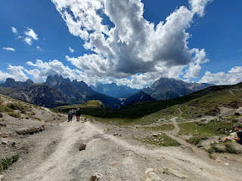

When you go downhill and there are a lot of rocks and crevices, you have to step more carefully. My left knee started seizing up with every careful and selective step. I tried shaking my leg out, to loosen up my knee, but then with the very next step it would protest loudly all over again . . .

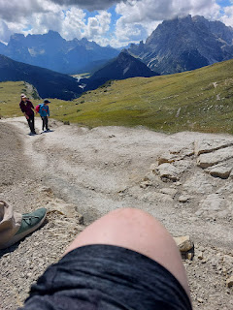

I sat down on a rock to apply some essential oils and to rest for a few. Once I started down the trail again, I found that it helped to change my body position to more of a sideways angle if it got pretty steep. Instead of facing forward, I turned to my left and let my right foot lead. Little by little we made it down the rest of the way.

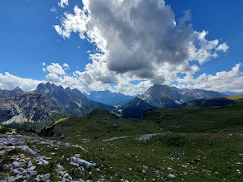

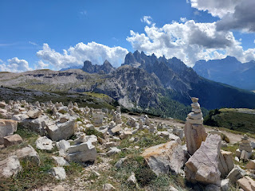

Hooray and Hallelujah when we could see the parking lot again!!

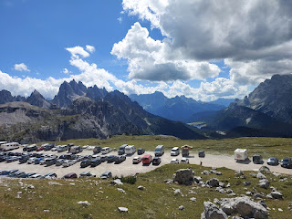

We were on the trail for about 5 hours from start to finish, which included rest stops and lunch. What a tremendous day and what a tremendous accomplishment!

Horses are my favorite animal on the planet, so I was very grateful when Scott agreed to pull over so I could take some photos of this magnificent creature.

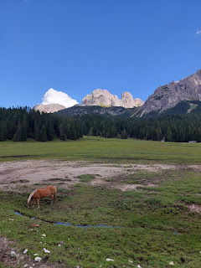

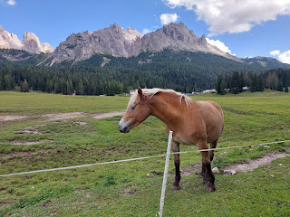

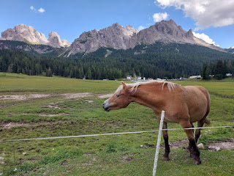

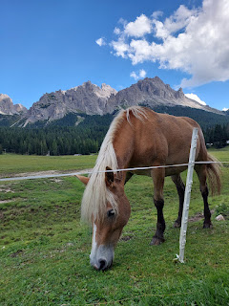

Video of her eating the grass next to me: (29 seconds)

https://photos.app.goo.gl/VVWRHXZKPBeKVk8x5

You can hear the bells on some of the other horses as they nibbled, even though this mare did not have a bell on.

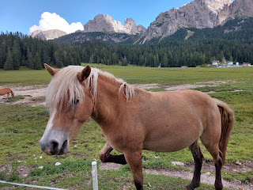

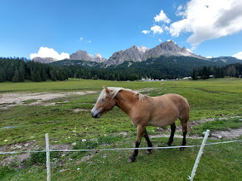

On the drive back to our hotel, I loved seeing these happy little critters smiling their goofy smiles at us . . .

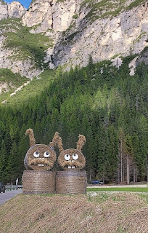

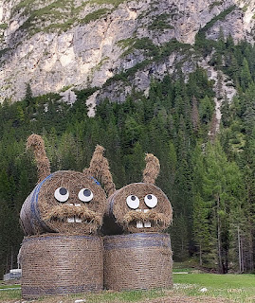

In the meadow next to our hotel, the cows were laying down in the grass to admire the views . . .

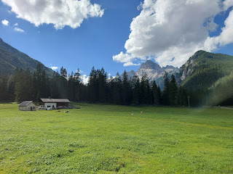

After a good long rest, and a hot shower to freshen up, we drove back over to Lake Misurina for dinner. This inviting fur-lined bench looked so cozy . . .

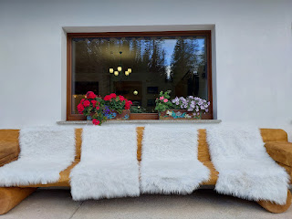

Lake Misurina from the north end looking south . . .

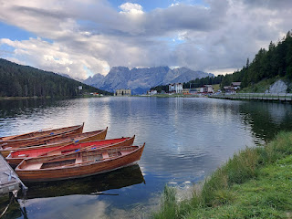

I bought a few trinkets in the gift shop before we walked down the street for dinner. Scott is usually a good sport when I like to browse. :)

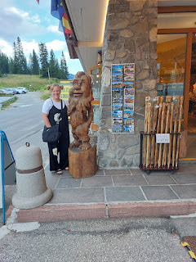

Lake Misurina - before dinner . . .

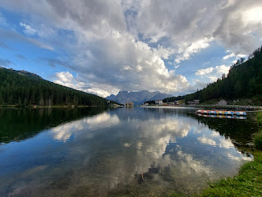

The view from our table was oh so lovely . . .

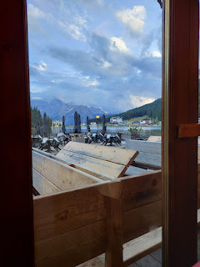

I chose the Filletino di Trota, while Scott ordered a tasty pizza.

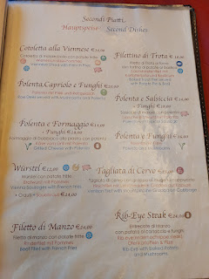

The mashed potatoes were pretty great, with the basil and olive oil drizzled on top. The trout was very good, too.

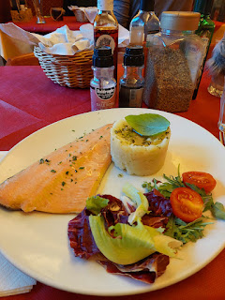

Lake Misurina (after dinner) . . .

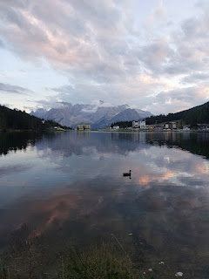

Sunday, September 3rd:

After a hearty breakfast, we checked out of the hotel and drove a little over an hour to get to the nearest church.

The lush green at the base of the gorgeous mountains made for a very pretty drive.

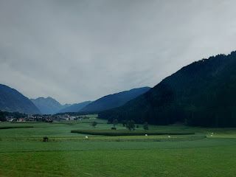

There were too many castles to count . . . and this one was right next to the freeway!

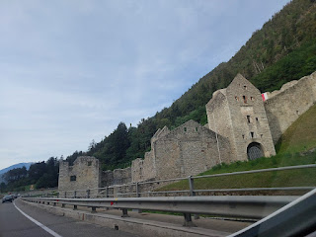

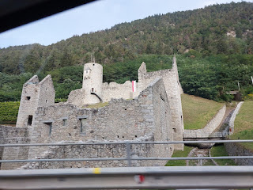

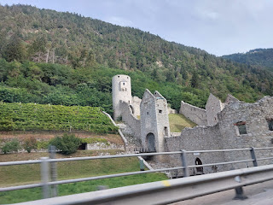

We met with a very tiny group of saints in a medium sized room on the 3rd floor above a car dealership in Brixen, Italy. They speak German as the primary language there . . . although they have a few church members who primarily speak Italian. Because the membership of the congregation is so small (about 25?), it is organized as a Branch instead of a Ward. And instead of a Bishop being in charge, there is a Branch President. In the Brixen Branch, the Branch President was approximately 25-27 years old, newly married about a year ago, with a baby girl due in one month. He was German, but spoke perfect English. His wife is from Spokane Valley, Washington. They were very friendly and visited with us for several minutes before church began.

Scott - outside the main door of the car dealership.

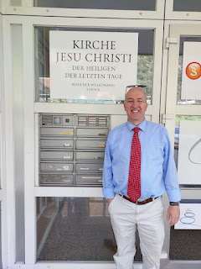

And me - outside the 3rd floor entry that leads to a hallway of small classrooms and the little chapel.

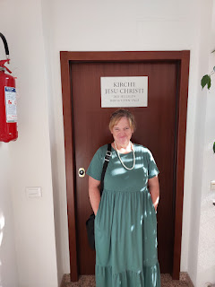

I absolutely LOVE singing in German. What a great way to learn pronunciation as you try to keep up with everyone else. It feels like I am meant to learn German in this life . . . I just need to get on that . . .

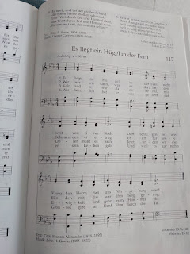

I took this photo after church was over, but this was the cute little chapel where we had Sacrament meeting.

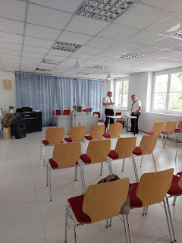

After Sacrament meeting, we were divided up into 3 groups for Sunday School: the German speakers, the Italian speakers, and the English speakers. We attended the English class, along with the missionaries, the Branch President's wife, a newly baptized member named Kennedy from Nigeria, and a young lady named Faith, also from Nigeria. We had a great discussion in our tiny little classroom and I was so grateful that we could participate with them. What a wonderful group of people, with faith-filled hearts, and a willingness to follow Jesus Christ.

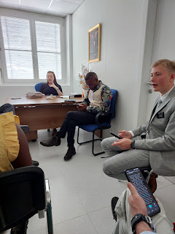

After church, we drove about 25 minutes SE to our next B&B in nearby Santa Maddalena, Italy. It is a very tiny community of approximately 370 residents, but the scenery is so incredible in every direction.

This was the view from our bedroom window . . .

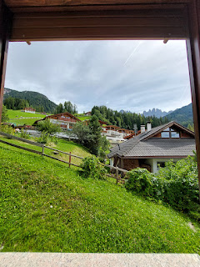

Video of the view, along with some cowbells clanging from a short distance up the hill: (17 seconds)

https://photos.app.goo.gl/So7sqwPjXTvW3XpLA

Cascades run along the length of the town, which we passed over just down the street from our hotel.

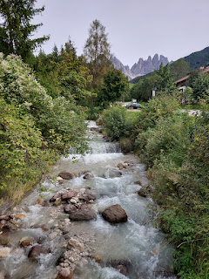

We came here for one main purpose: to hike up to the Chiesa di Santa Maddalena and to see the panoramic view of the valley from the trail above the church.

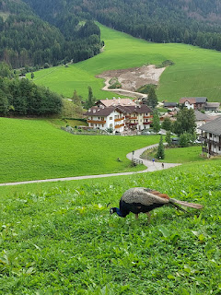

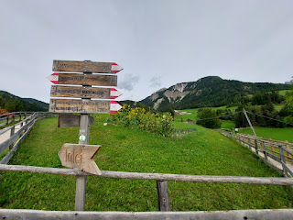

Everything has an Austrian influence up here: the homes, the food, the landscaping, etc.

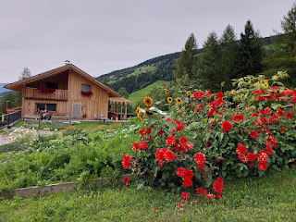

Chiesa di Santa Maddalena has a long history: it was originally built in the 14th century, but only the tower remains from 1394. The rest of the add-ons are from the late 1600s and beyond.

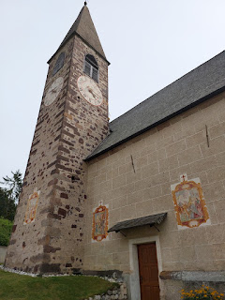

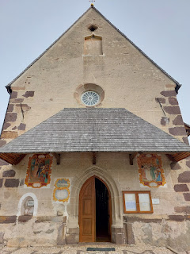

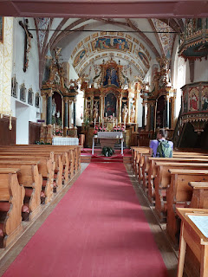

In a small alcove outside the main entrance lies an artistic rendering of Christ's broken body, a reminder of His love for each of us. Some religions are very literal, though.

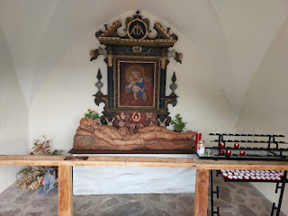

In the front courtyard is a local cemetery.

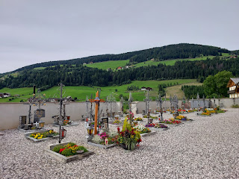

I love the memorial markers in this part of the world because they typically include photos of the deceased.

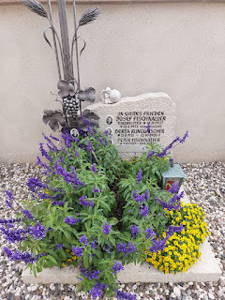

Along the trail up to the church there is a very old Madonna in a protected shrine. I assume that because Italy is a very Catholic country, they pay homage to the Mother of Jesus in a variety of ways.

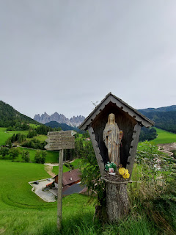

We continued our walk beyond the church, with some rich and rewarding views of the Val di Funes.

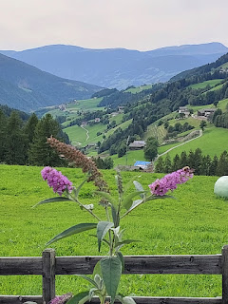

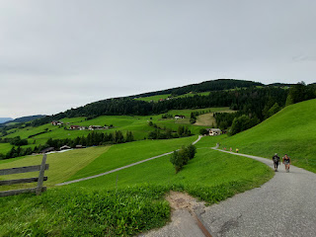

This is the sign that we were looking for . . . it leads to one of the most panoramic views in this whole area.

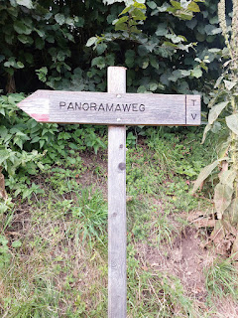

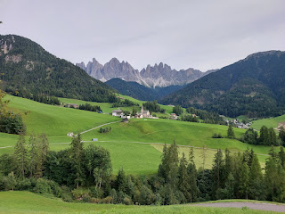

How absolutely gorgeous!! I would love to see this view at the peak of every season.

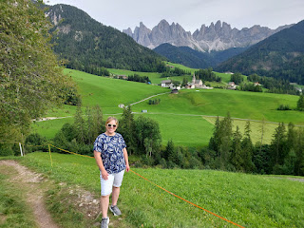

Scott, posing for me . . .

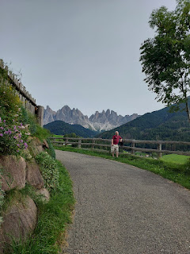

Do you remember the scene in The Princess Bride, where Wesley tumbles down the long and steep hillside, shouting, "Azzzz....youuuu....wishhhhh...."? Well, this hillside reminded us of that . . .

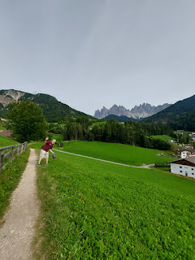

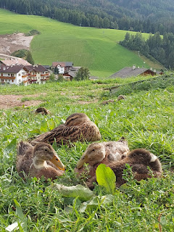

Scenes from around town on our walk back to the hotel . . .

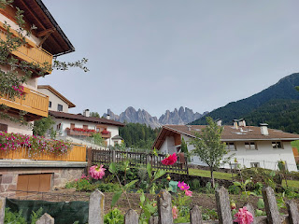

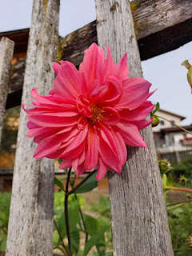

A map of the region . . .

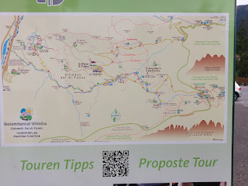

I loved the arched front door of this house around the corner from our lodging.

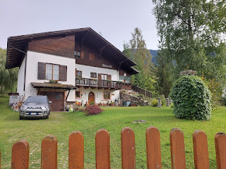

This old barn is directly in front of our hotel. On the left, outside, is a chicken coop. Inside there are several bunny hutches with a sleeping bunny in each one. Adorable.

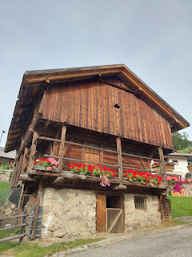

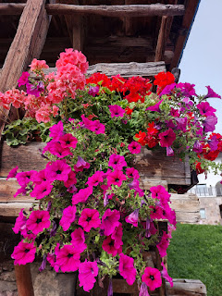

I even loved how they hung all their onions on the outside of the barn.

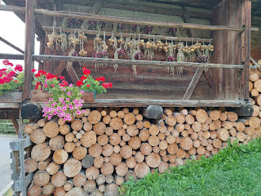

This was the front of our hotel: Pension Sonia Apartments.

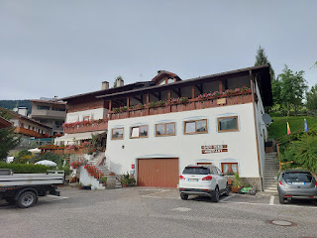

We ate dinner at the Hotel Fines, a one minute walk from our hotel. I chose the South Tyrol Beef Goulash with 2 giant dumplings, and a few carrots and parsnips, along with a marinated side salad. Scott ordered a giant burger that he could barely maneuver, resorting to using a knife and fork in order to consume it. My goulash was the perfect comfort food and I enjoyed it very much.

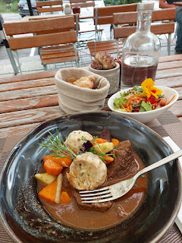

After dinner, we went for a nice long walk until we started to get chilly in our short-sleeved shirts.

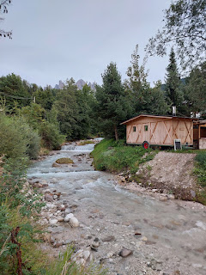

As I mentioned earlier, this crystal clear river flows through town and is very soothing.

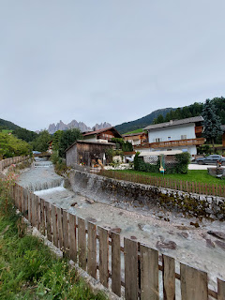

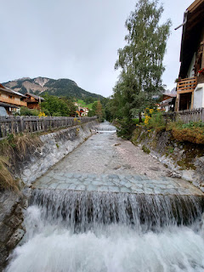

Video of the river for those who need to hear the sounds of it: (11 seconds)

https://photos.app.goo.gl/kSGNbRRcZNuDbLxk9

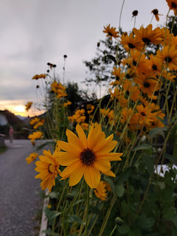

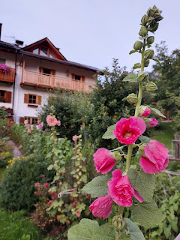

I took several photos of the local gardens to share with my sister, Charmaine. This one was her favorite. (below)

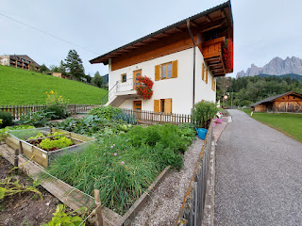

We marveled at the contrasting old vs new styles of homes in such a tiny community.

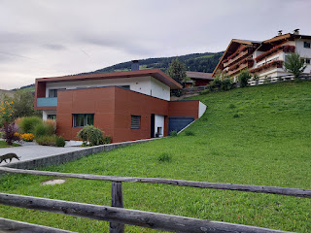

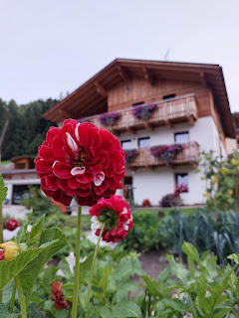

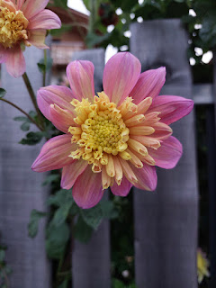

They even know how to dress up a woodpile . . .

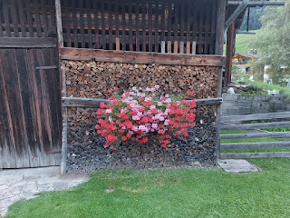

I absolutely fell in love with Santa Maddalena. If it weren't so far away from an international airport, I might consider living out my retirement years in a place like this. I had the nicest nap on Sunday afternoon, with peace and quiet emanating in through our open window and only the faintest sounds of cowbells off in the distance.  I can't even remember the last time I took a nap, but this one might just be my favorite nap of all time.

This was a perfect weekend to spend with my best friend, high up in God's country. The rest of this next week might be boring, but that's okay. My heart is filled to the brim with gratitude for so much. I am thankful for my husband, for a safe flight, for the beauties of the earth, for good people everywhere, and for my children and grandchildren. I am always wishing I could share every single thing about Italy with them . . . maybe that's why I take so many pictures. Someone once told me, "Take a picture, it'll last longer." Even though it was said with a hefty dose of snarkyness 40+ years ago, it actually does make good sense.